**Wind Energy Conversion Systems**

**Assignment 2**

**Muhammad Shamaas**

**ID # 2018-MS-EE-4**

**Introduction**

This case study investigates the Induction machine modeling in Complex Vector. The first example analyzes the free acceleration of a singly excited, 6 pole, 3 phase, 220V (line-to-line), 10hp, 60 Hz induction machine. The machine is at standstill state with no load torque applied. Nominal voltage will be applied at its stator. The machine will accelerate to reach a nominal speed. This process of acceleration is call “free acceleration”. The second example illustrates the consequence of DFIG stator voltage drop in rotor currents.

The dq0-axis model of the induction generator can be obtained by decomposing the voltage, current and flux linkage space-vectors into their corresponding d-, q- and 0-axis components. This is known as Park’s Transformation.

The αβγ stationary reference frame is derived from dq0-axis rotating reference frame by putting θ = 0 and . The transformation of three-phase variables in the stationary reference frame into the two-phase variables also in the stationary frame is often referred to as abc/αβγ transformation:

Similarly, the two-phase to three-phase transformation in the stationary reference frame, known as αβγ/abc transformation, can be performed by:

**Example 1: Free Acceleration**

A simulation complex vector-based model was built in Matlab/Simulink to demonstrate the dynamics of free acceleration of an induction machine. A complex vector was treated as two real variables with the q-axis is leading the d-axis by 90°. A complex vector can be expressed as:

Since zero-sequence currents do not introduce magnetic field, the zero-sequence circuits of stator and rotor are decoupled. All variables are in per unit.

Induction Machine dq0-axis Reference Frame Model Equations

1. Voltage Equations:
2. Current Equations
3. Motion and Torque Equations
4. Arbitrary Reference Frame d-, q- and 0-axis circuits for 3-phase Induction Machine

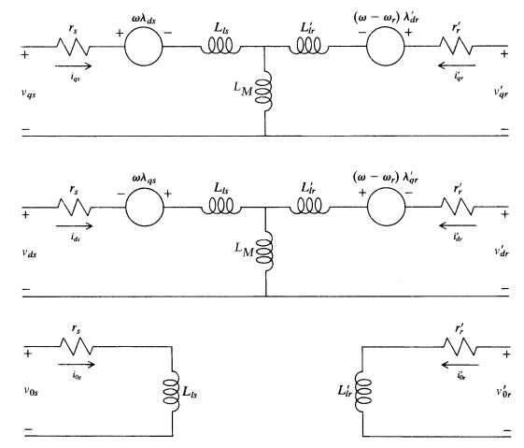

SCIG Machine Constants

1. Rated Line-Line Voltage
2. Number of Poles
3. Rated Stator Frequency
4. Stator Winding Resistance
5. Rotor Winding Resistance
6. Stator Leakage Reactance
7. Rotor Leakage Reactance
8. Magnetizing Reactance
9. Inertia Constant
10. Base Speed
11. Synchronous Speed

Initial Conditions (t = 0-)

In this case, the IG model in the synchronous reference frame should be used, which was realized by setting the speed of the arbitrary reference frame to zero (w = ws). The dq-axis rotor voltages are set to zero for simulation of squirrel-cage induction generators.

1. The reference frame is rotating at synchronous speed
2. Electrical Frequency
3. Rotor Speed
4. Stator Voltages
5. Rotor voltages are zero
6. Stator and Rotor Currents
7. Electromagnetic Torque is zero
8. The rotor is not loaded

Simulink Model

The input variables of the model include the dq-axis stator voltages vds and vqs, rotor voltages vdr and vqr, the mechanical torque Tm. The output variables are dq-axis stator currents, ids and iqs, dq-axis rotor currents, idr and iqr, the electromagnetic torque Te, and the rotor speed wr of the generator.

1. Block diagram for dynamic simulation of SCIG in free acceleration.

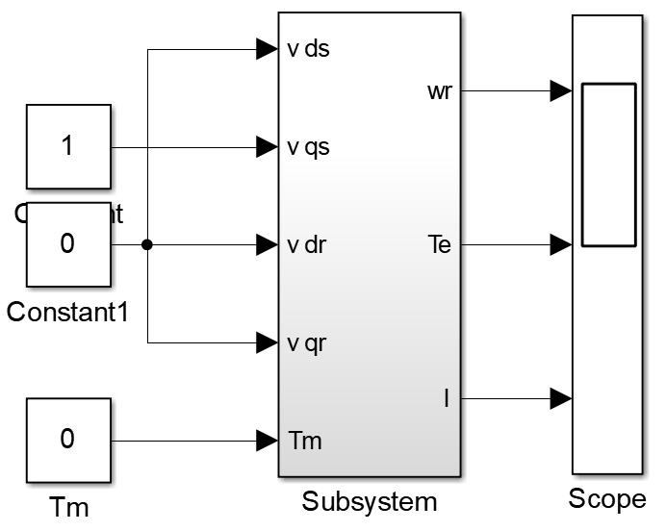

1. Block diagram for dynamic simulation of an induction generator in the synchronous reference frame

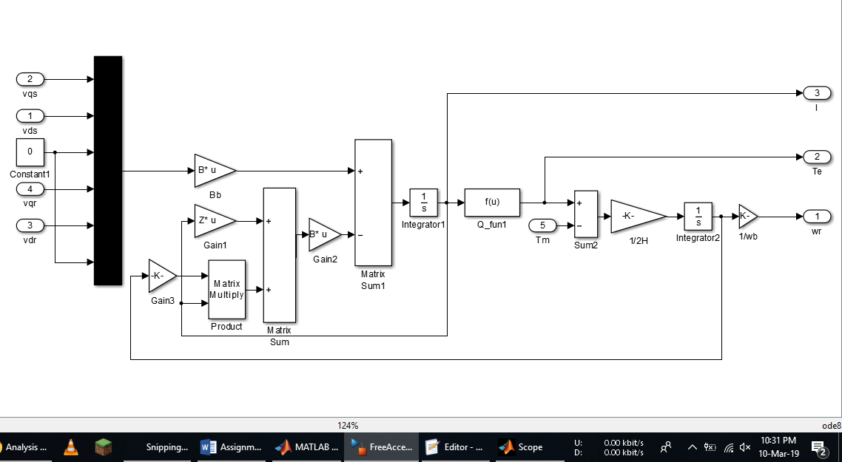

1. WECSConstants.m

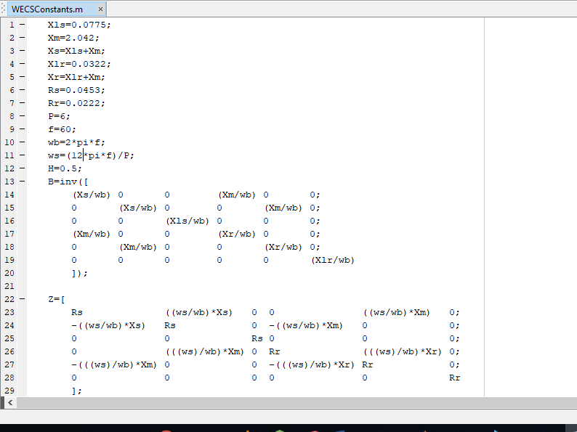

Results

1. Currents (iqs, ids, iqr, idr)

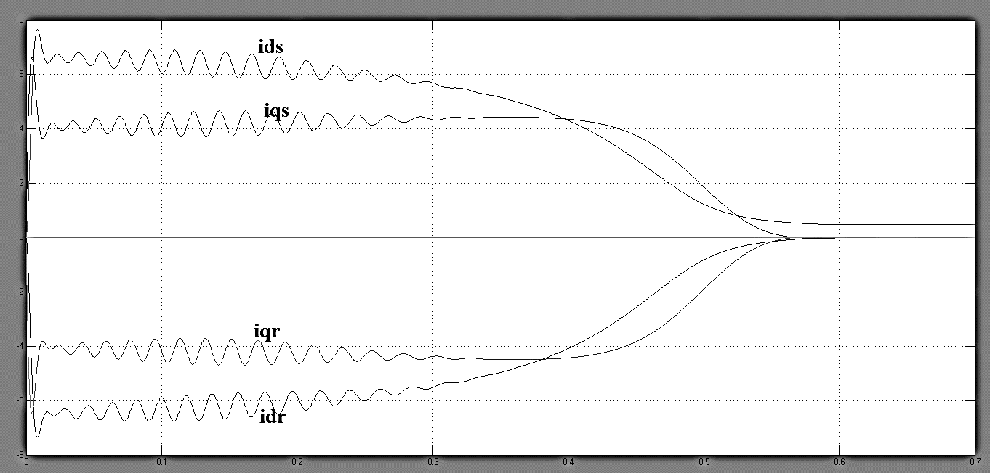

1. Electromagnetic Torque

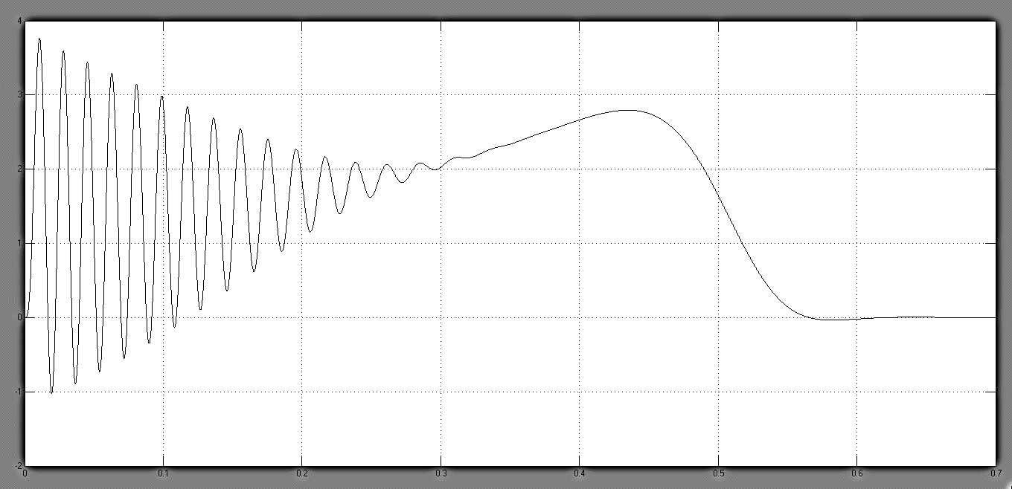

1. Rotor Speed (wr/wb)

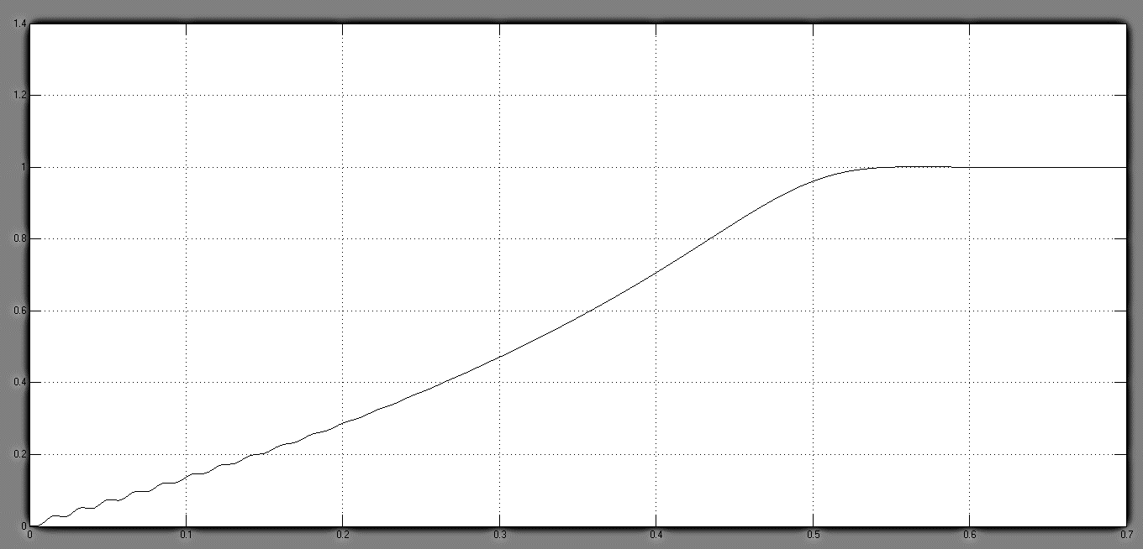

During the system transients, a high inrush current flows into the induction generator. As a rotating magnetic field is being built and generator core is being magnetized by the stator current, an electromagnetic torque Te is produced. Since the generator operates below synchronous speed in motoring mode, it produces a positive torque that accelerates the turbine. The generator finally reaches the synchronous speed of 376.99 rpm (1 pu) at t = 0.6 sec, at which it enters the steady-state operation with Te= Tm = 0. The direct connection of the generator to the grid during the system start-up causes excessive inrush currents with peak values of 7.6 per unit (pu), high electromagnetic torque (3.75 pu, peak), as well as high torque oscillations.